3.6 I can select and use different elements to control environments for collaborative technologies

Rich text editors allow you to write directly into a website without needing to use any html code. You can add text and images, create tables and embed files. Rich text editors are also referred to as WYSIWYG (What You See Is What You Get) editors as content is shown exactly how it would in the finished product. In the example below I have used a rich text editor called CKEditor 4 to create a draft of a website page;

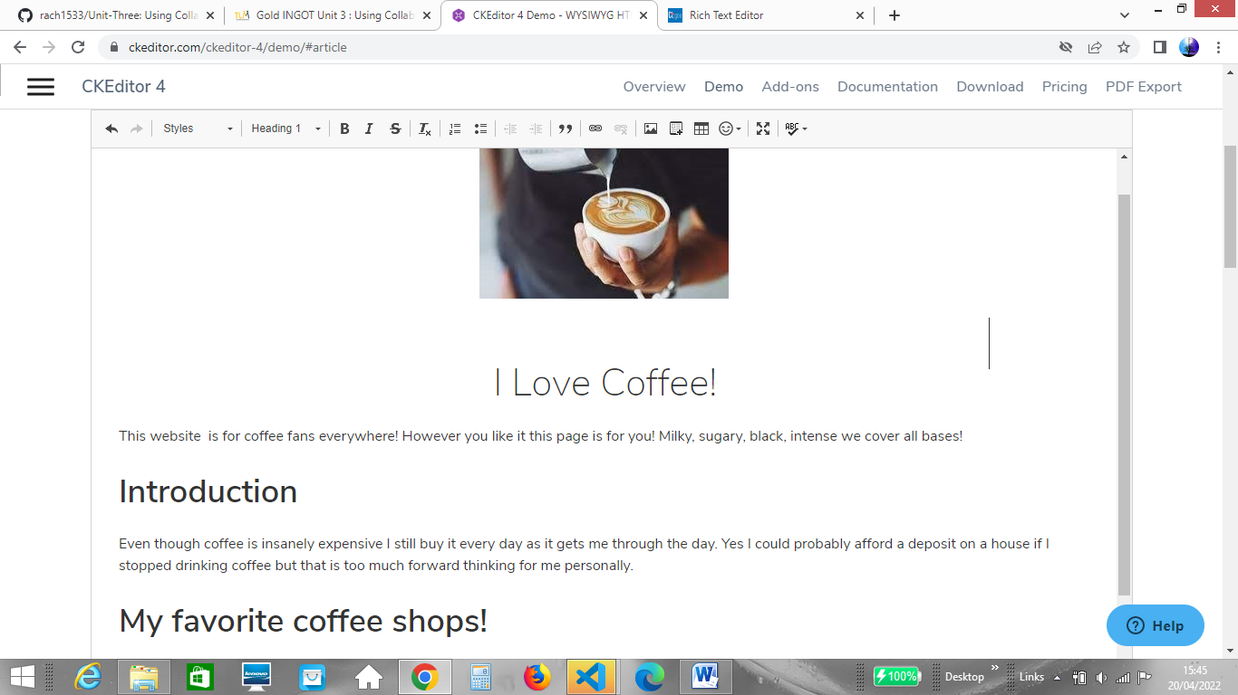

Environmental factors that affect the workspace

When working with equipment such as laptops, desktop PCs and related hardware such as keyboards, computer mouses and headphones, it is important to consider the ergonomic factors that could impact on safe and efficient working. For example, when working with computer screens it is best to position the screen away from direct sources of light such as sunshine which could create a glare on your computer screen you should also rest your eyes at regular intervals. Not complying with this guidance could cause unnecessary eye strain resulting in eyestrain and headaches.

To avoid back pain, when sitting at a desk top PC you should ensure that you are sitting up straight, keeping your neck as straight as possible. The top of your computer screen should be level with your eyes. Your feet should be flat on the floor and you should use a foot rest if your feet cannot reach the floor whilst sitting in your chair.